Installing CTIS on a NON-CTIS HMMWV
By: Scott Pouls

Parts Required ($$):
- 4 CTI Equipped Geared Hubs, or a combination of CTI Spindles and Steering arm covers (to retrofit non-CTI hubs)
- 4 CTI Protection covers (bolt onto steering arm cover)
- 1 CTI Selector Valve (if using the original one solenoid system)
- 1 CTI Deflate Valve (civilian valves will work since they operate at 6v-48v)
- 1 Green CTIS Dash Light (Military)
- 1 CTI 3way toggle switch (constant on, constant off, toggle deflate)
- 2 Stewart Warner Air Pressure 490ABK Gauges (1 front 1 rear)
- 1 CTI Pump (24v if military 12v if civilian)
- 1 CTI ready Dash board
- Mounting hardware for pump
- 1 One way air check valve (pop-off pressure of 1-2PSI must be able to hold 55PSI)
- 4 - 3/8” brass tee’s
- 1 Over pressure valve (pop-off at 55 PSI)
- 4 Long 3/8” barbed connectors (to go into steering arm cover)
- 10 - 3/8” barbed fittings
- A few double sided barbed fittings (incase you cut hose to short)
- 1 CTI equipped Air horn
- 1 fitting w/barb for air horn
- Approx 50’ of air hose 3/8”ID (can buy in bulk at virtually any hardware store)
- 4 Wheel side connectors (perhaps home made CTI lines)
- 4 CTI protector covers – wheel side (perhaps Blue Hummer covers)
- 2 - ¼” tees (for pressure readings at gauge)
- 2 - ¼” fittings to accept tubes with crush fittings
- Approx 20 Hose clamps
- Zip ties (or some other way to tie the lines back)
- Electrical wire Approx 50’ red and 50’ black (can use regular military wire and connectors, must figure out the best way to label them though)
- Electrical connectors
- 1 in-line fuse holder
- 1 15a fuse (for civilian use 30a fuse)
- Misc. nuts and bolts for mounting equipment
- 1 CTI Selector Switch decal

Tools Needed:

- Standard tool set
  - Socket sets and open end wrenches
  - Pliers
  - Screw Drivers
- Electric Drill
- Drill Bits
- Ohm / Volt Meter
- Pickle Fork – Use as needed
- 5lb Sledge Hammer – use as needed
- Wire strippers
- Soldering Iron
- Electrical Tape
- Torque Wrench – Use as needed (Torque List)
- Spray Bottle with Soapy Water – Key to any CTI System

NOTE: This setup doesn’t include any warning lights for low pressure, I STRONGLY Recommend that you only install a setup like this with beadlocks, or modify the system to incorporate a low pressure light / buzzer.
Procedure:

First, and probably the most important job is to layout where you want your CTI pump, CTI deflate valve, and other accessories. When I did this conversion on my ’85 M998, I chose to put my CTI pump under the passenger rear seat. All of the AMG produced models have this equipment under the hood, but in that location, over time many people have found there to be issues with their pumps / valves due to exposure to salt, water, mud and sand. In a Humvee, the seat bases are hollow and are generally used for storage.

For the CTI lines (and electrical lines), I decided to route them from that seat base compartment between the frame and body tucked up high enough so that they can’t drag or catch on anything while off-roading. They then went to their respective locations.

The most labor-intensive part of the procedure is to outfit the geared hubs with the CTI ready spindles, or to fully replace the geared hubs. If your desire is to install CTI equipped spindles and steering arm covers, Chuck Kopelson has written an article on how to replace a geared hub output seal, which can be used to show how a geared hub spindle can be replaced (another article to take a look at is Gear Reduction Hubs Also found on Chucks site). If you were to replace the whole geared hub, there is an article on the Humvee.net website showing how to remove the ball joints and replace them.

Changing out the geared hubs – Things to watch out for

- Steering stops are in the correct place and correctly adjusted (see service manual)
- Steering arms are correct in angle as seen in figure 1
- Vehicle is properly aligned after the new steering arms / hubs are installed
- Ball joints / tie-rods are properly torqued and bad ball joints / tie-rods have been replaced

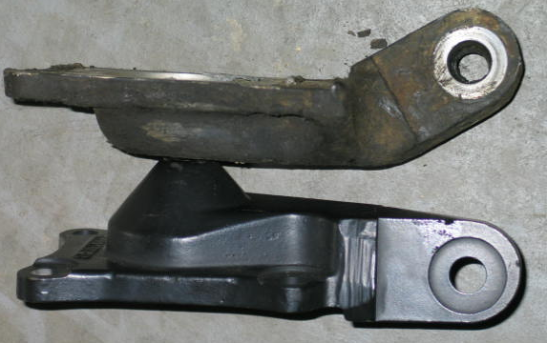

Figure 1. Differences in Steering Arm Covers

The difference between a CTI equipped geared hub and a non-CTI equipped geared hub is simply a hole inside the spindle and steering arm cover. The non-CTI geared hub has a sealed spindle and a sealed steering arm cover. A CTI equipped geared hub is pictured in figure 2.

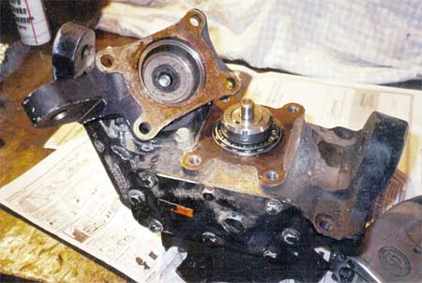
CTIS Hub Seal - CRITICAL

Figure 2a. A CTI Equipped Geared Hub

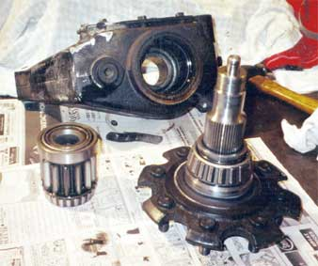
Figure 2b. CTI Equipped Spindle removed from geared hub

After this job has been completed, you can now move onto mounting your compressor and CTI deflate valve. Again, I mounted my valve in the passenger rear seat compartment since it would be out of the elements during my off-road adventures and everyday driving, your location may vary from where I placed mine. This has been depicted in Figure 3.

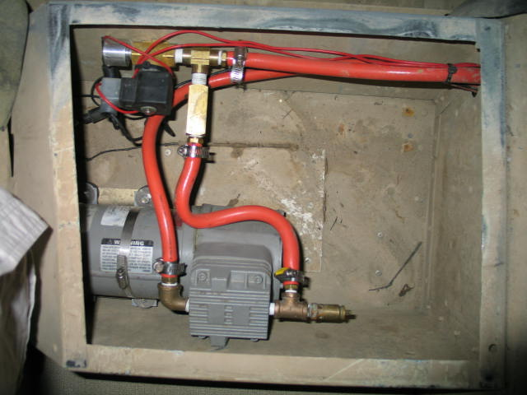
CTI Pump
Deflate Valve

Figure 3. Mounting location of the CTI Pump and Electric Deflate Valve

Next, the airlines can be run. The long barbed connectors can be installed to the steering arm covers to accept the air hose. Then, the air hose needs to be assembled in the manner layed out in figure 4.

CTI Selector Switch

Tee
Tee

Engine

CTIS Pump / Valve

Figure 4. Schematic of Airlines

To help explain the picture, the green line in figure 4 comes from the air horn on the engine and supplies filtered air to the CTI Pump. The blue line comes from the CTI pump and sends this filtered / pressurized air to the CTI selector switch. From the selector switch, the air can be moved to either the front or rear tires. Note: I didn’t show the hoses going to the CTI Gauges, they will be shown later

Some warnings about mounting airlines

- When installing the airlines be sure to tuck them ABOVE the frame rail, or within the frame rail for clearance to the ground
- Be sure to NOT place airlines near exhaust, if this cannot be avoided, you need to put a heat protective wrap on the line so it will not melt
- Avoid putting air lines in “pinch” areas where the body can move relative to the powertrain or frame / suspension
- Allow some “slop” in the lines when attaching at the wheel to account for wheel travel and steering
- Remember to secure them good enough so they will not fall or move around while extreme off-roading
- Remember to keep them out of the way of moving components (half-shafts, drive-shafts, linkages etc.)
- Label ALL lines while routing them – saves time in the long run

After the hubs, CTI Pump, deflate valve and airlines are installed, there isn’t a whole lot of stuff left to do. The electrical harness needs to be created, a new dash installed, the gauges installed and the selector switch needs to be mounted and situated in the vehicle. Before mounting the CTI selector switch, be sure to look at both the switch and the decal you will be using to ensure that when your switch lever is in one position it matches up with the position on the decal. The air inlet to the selector switch is straight back from the lever and the two outlets perpendicular to the inlet are to the front and rear. You will need to install hose barbs in these locations to attach the respective hoses onto the switch.

Creating the Electrical Harness

The electrical system for this project is really very simple. Since my system was 24v, on a civilian truck (or a modified HMMWV) this would need to be altered. From the positive battery terminal (positive going to the body harness – NOT the positive that is bridged to the opposite battery) take a wire and run it up to the switch located in the dash. This wire will need to be fused, incase of an overload in the circuit. Since at 12v the system needs a 30a fuse, when running at 24v, the system only needs a 15a fuse (V = I*R – Ohms Law). Place this fuse somewhere between the battery and the switch; I prefer the location to be under the dash. See figure 6

The switch that was used in this project is an actual military switch your switch may vary. The switch has a positive input and two switched outputs (4 wires). With aid of an ohmmeter, I was able to determine which output was the constant on and which was the toggled on (when placed on two terminals, when switched the ohmmeter will jump – similar to when the two probes are touched together). From the constant on, I ran a wire to the positive side of the CTI Pump. The toggled on went to the CTI Deflate valve. The negative side of the pump and the deflate valve can be combined and ran to a common body ground. Since I have established a common body ground on my HMMWV already, I used that point as the ground point for the CTIS. See figure 5

Switched Constant On (Pump)
Switched On (CTI Light)
442
438

Positive Fused Input (24v)
597

Switched Toggled On (Valve)
436

Figure 5. CTIS Switch Wiring Diagram

436

Deflate Valve
437

CTI Pump
57
438

442

CTI Switch

CTI Light
--
+
--
+

12v Battery 12v Battery

Figure 6. CTIS Wiring Schematic

As stated previously, when creating the CTI harness, if the system will be used at 24v, the standard military wire is sufficient. If it will be created at 12v, this will not be sufficient and will need to be upgraded. The lines from the switch to the light will match
i.e. female to male.

Some Warnings about Wiring Harness Location

- When installing the electrical lines be sure to tuck them ABOVE the frame rail, or within the frame rail for clearance to the ground
- Be sure to NOT place electrical wires near exhaust, if this cannot be avoided, you need to put a heat protective wrap on the wire so it will not melt
- Avoid putting electrical wires in “pinch” areas where the body can move relative to the powertrain or frame / suspension (potentially shaving the insulation off the wire)
- Remember to secure them good enough so they will not fall or move around while extreme off-roading
- Remember to keep them out of the way of moving components (half-shafts, drive-shafts, linkages etc.)
- Label ALL Lines While routing them – saves time in the long run
Pressurized Air Line
Pop Off-Valve
One Way Check Valve
Filtered Air Inlet to Pump

Figure 6. CTI Pump & Deflate Valve Layout Description

Note: The one-way check valve must be oriented properly in the line (arrow on the valve) or it will NOT work. The pop-off valve MUST be included otherwise damage to the pump due to high pressure can occur.

CTI Selector Switch

At the back of the CTI Selector switch, there will be one inlet and two outlets. On the outlets, you will need to install a tee. On this tee there will be one barbed fitting accepting the air hose going to the respective system (front or rear) and there will also be a crushed fitting to accept a ¼” ID hose that can then be run up to the gauge. See Figure 7

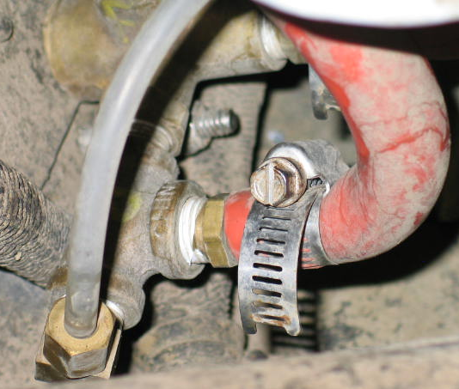
Pressurized Input
Tee
Pressurized Gauge Output
Pressurized System Output
CTI Selector Switch

Figure 7. CTI Selector Switch, Back Side

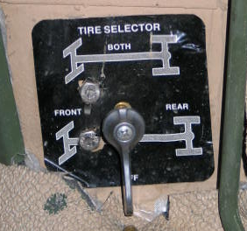

Figure 8. CTI Selector Switch, Front Side

CTI Wheel Side Connectors

As stated previously the cheapest way to create the wheel side CTI lines is to use the outlined parts in the article listed on the HML (home made CTI lines). Any Hummer CTIS line will work as long as it is compatible with your particular wheels.

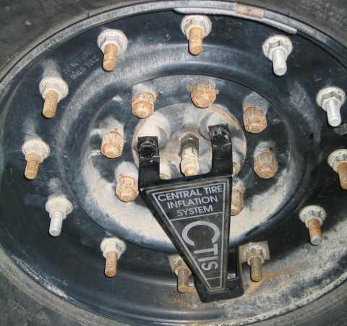

Figure 9. Wheel Side CTIS Lines

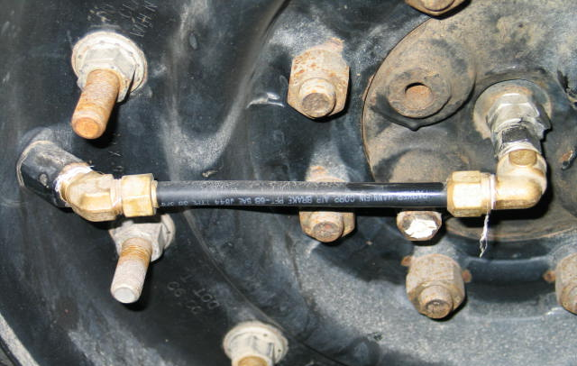

Figure 10. Home-Made CTIS Lines

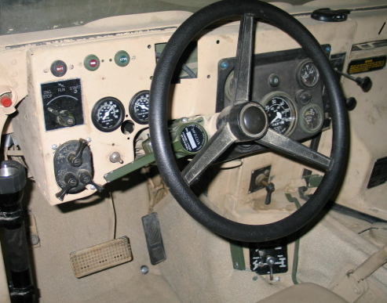

Figure 11. HMMWV CTIS Equipped Dash (Note: gauge light is not installed)

Once everything is installed, run the system and check for leaks using a spray bottle with soapy water. You will find leaks and generally the system just needs to be tightened up. If you don’t have runflats in your tires, you will want to have your truck on jack-stands when installing the CTI lines on the wheels. If you have the tires deflated with the trucks weight on the wheel, you can un-seat the bead of the tire, which can be very difficult to get back on without proper equipment. If there are any electrical issues, first double check your connections; second follow your lines back to make sure that you have the right one to accomplish the given task. If this still doesn’t work, you might want to console in troubleshooting with your ohmmeter. Be sure to put some miles on your truck before you take it off-road with the new system, this can work out bugs that you don’t want to find while off-road.

Some Trail Spares that are good to have with you are as follows:

- ¼” Allen head Plugs - 8
- Screw In Schrader Valve – 4
- 3/8” O-ring if using the Home-made CTIS Lines – 4 (these can be easily damaged by not installing them properly into the female fitting ALWAYS keep extras on hand)

