Fitting CTIS to a Hummer/Humvee

Fitting CTIS to a Hummer/Humvee that was not originally equipped with it from the factory can be done with totally original parts or with a mix of original and aftermarket bits and pieces.

Most Hummers from mid 90’s on would have it fitted or be “CTIS ready” in that the mechanical (geared hub) would already be fitted with the necessary bits to enable it to be installed.

My 1988 M1026 was never fitted with it or even fitted out to be “CTIS ready” like later Humvee’s so to fit the entire system was a major job.
The mechanical differences between non CTIS hubs and CTIS hubs are:
The rear steering arm cover on the hub is different, it has a seal and a hole to enable the air to pass through. LH front and RH rear caps are part number 6005121, the RH front and LH rear are 6005120. These covers were already fitted with the seal (part no. 6005193) and retaining clip (p/n 5594472) so you don’t have to buy the seal and clip separately.
There is a spacer between the rear bearing cone and the hub body to space the cone rearwards approximately 1/8” to act as a locator for the rear steering arm cap, part number 6001784.
The spacer between the output gear and the rear bearing is changed from 6009400 to a new one 6009350 which is thicker.
The CTIS spindle has a 3/8” hole through the middle for the air passage part number 6009349 but they are very expensive, around $700 each.
I decided to machine the existing spindles, drill the 3/8” hole through the centre and bore it to the correct size to take the stainless steel spindle extension (part no. 5594531) on the inner end. I also had to drill and tap the ¼” NPT thread on the outer end as well. If you have access to a lathe it isn’t too hard to do and even if you had to have the spindles machined at a machine shop it would be far cheaper than new spindles.
You also need to buy the later style (shorter) radius rods (for the rear) and tie rods for the front as the arms on the covers where they attach are shorter and straighter.
Me being cheap I just cut about ½” off each end of both tie rods and both radius rods. Don’t forget to cut the slots in the rods slightly longer as well so that the clamps will squash them when fitted.
Once the mechanical bits are out of the way you can decide which way you want to fit the system out, either a mechanical type selector switch like the early and military trucks or electrical like the later Hummers.
I chose the early system using CTIS selector valve p/n 5598990 and the matching decal 6003957. and the twin needle air gauge from the 1996 civilian Hummer.

I used 3/8” high pressure nylon tube and cad plated brass quick connect fittings throughout the air system rather than use the original type fittings due to local availability and ease of installation and possible future repairs. I have even used the nylon tube right down to the rear of the hubs, time will tell whether I will need to fit the braided flexible lines.

I already had a 5cfm 24v air compressor rated for continuous duty fitted to the truck along with a 10 litre air tank fitted with relief and one way valves.
I fitted a regulator/dryer set at 50psi on the outlet of the tank, then a 24v solenoid for inflate and then between it and the CTIS selector valve another 24v solenoid teed off the line for the deflate valve. These two valves are operated by a On-Off–On switch inside, up for inflate, down for deflate. There is a seperate switch to operate the compressor as well.
I made up my own CTIS lines for the wheels using the part numbers in the article on the HID.
I also made CTIS line protectors like the ones on the HID which utilise a flat bar across the wheel.
A brief parts summary:

2 off CTIS hub covers p/n 6005121 approx $120 each
2 off CTIS hub covers p/n 6005120 approx $120 each
4 off CTIS spindle seal p/n 6005193 approx $14 each
4 off CTIS spindle seal retainer clip 5594472 approx $3 each (If you buy new covers they are already fitted with this clip and the seal above)
4 off CTIS spindle extension p/n 5594531 approx $42 each ( I was cheap and made my own)
4 off spacer spindle bearing p/n 6009350 approx $22 each
4 off spacer – bearing p/n 6001784 approx $24 each
4 off CTIS ready spindles p/n 6009349 approx $700 each ( I was cheap and machined the old ones)
1 off CTIS selector valve p/n 5598990 approx $28 each
1 off Decal for the valve p/n 6003957 approx $2 each
2 off later style tie rods ( I just shortened the existing ones, see text)
2 off later style radius rods (I shortened the existing ones, see text)
2 off rear CTIS line protectors p/n 5598234 (I made my own)
Approx 15 metres of 3/8” high pressure nylon air line
3 off 3/8” cad plated brass push in quick connect T fittings (one for the front, one for the rear and one for the deflate valve)
Assorted air fittings to connect air gauges, selector valve and solenoids. As I said in the text I used push in quick connect fittings throughout.
4 off 3/8” cad plated brass ¼” NPT push in quick connect fittings (to connect air line into the back of the hub covers)
5 sets of CTIS lines for the wheels, I used the ‘homemade’ ones with Parker fittings from McMaster Carr as per the article on the HID.
4 off CTIS line protectors for the wheels. I made my own using the article on the HID which has aflat plate mounted across the wheels.
2 off solenoid valves (12 volt for a Hummer and 24v for a Humvee) for inflate and deflate. The original parts were pretty expensive so I got two 24v Parker solenoid valves off Ebay for $20 each.
1 off toggle switch (on-off-on) to operate the valves
2 off pressure gauges to show air pressure in front and rear tires. I used the 1996 hummer dual needle gauge.
1 off air compressor, the standard Hummer or Humvee compressor is apparently rated at 3 CFM, I already had a 5 cfm compressor and air tank in the truck so used them. The compressor is a Pro 7 sold by www.probag.com.au
I also fitted a dryer /regulator to the tank outlet to limit the air pressure into the CTIS system and to ensure no moisture entered the system as well.

If anyone wants any more info email me on pjames3@bigpond.net.au

Peter James
1988 M1026, RHD, 4L80E, 242 transfer, Aircon and CTIS

CTIS line

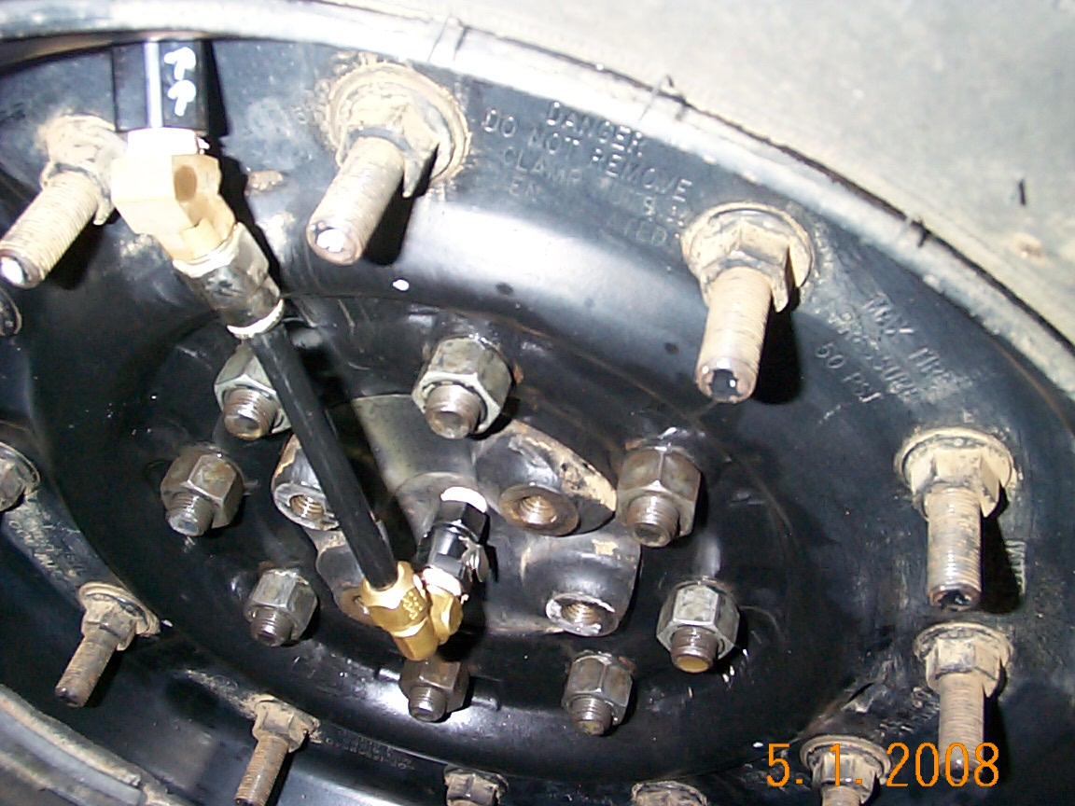

CTIS guard
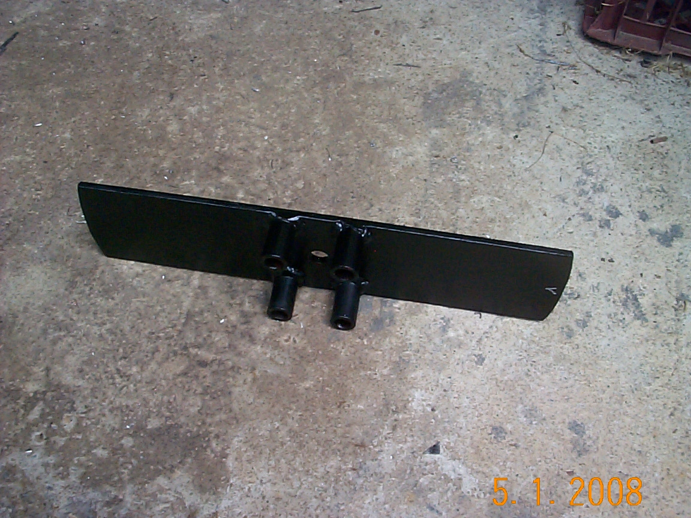

CTIS guard fitted

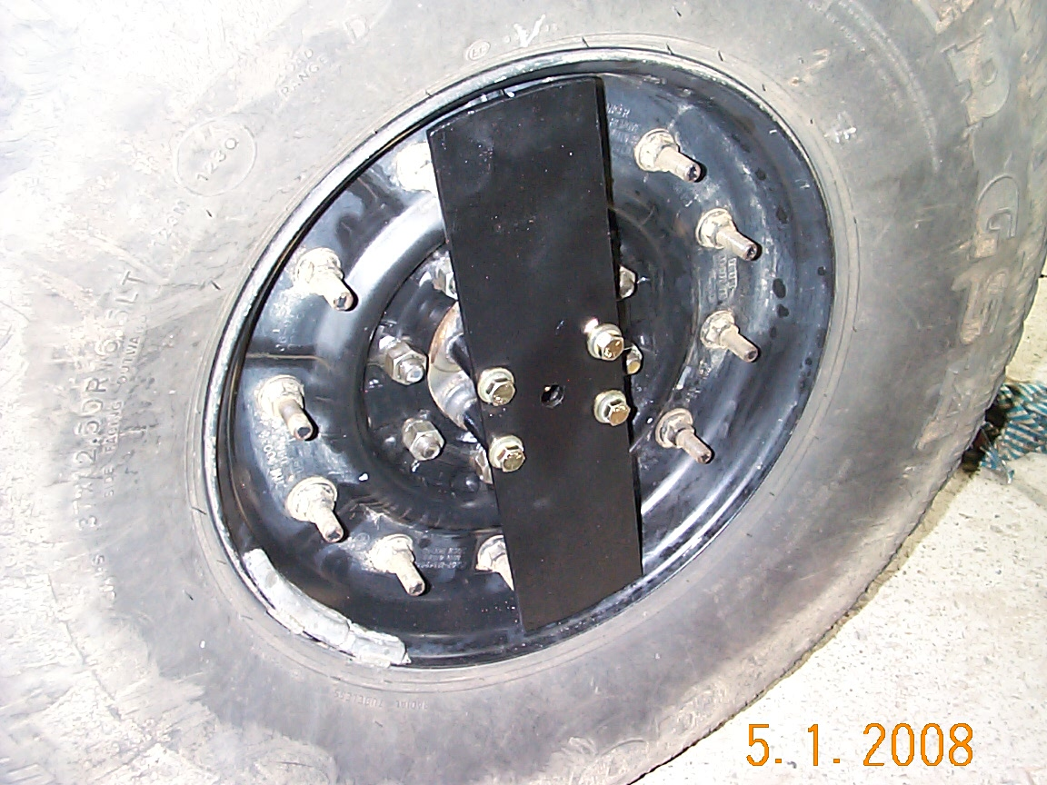

Quick connect into hub

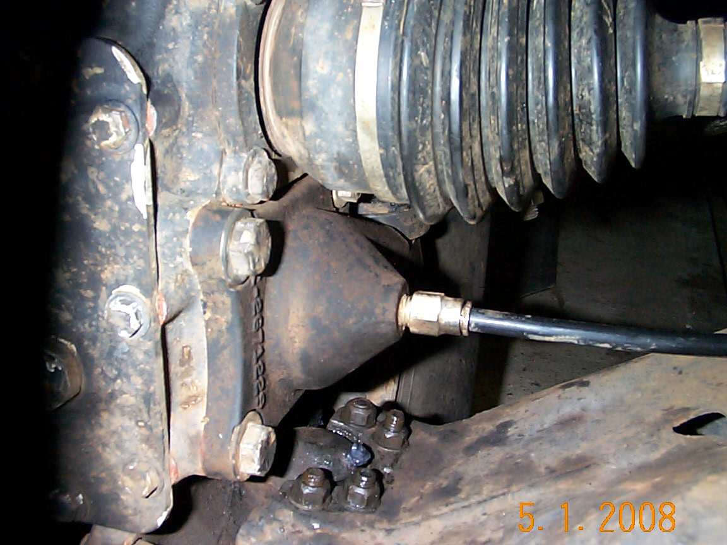

Quick connect fitting and nylon air line

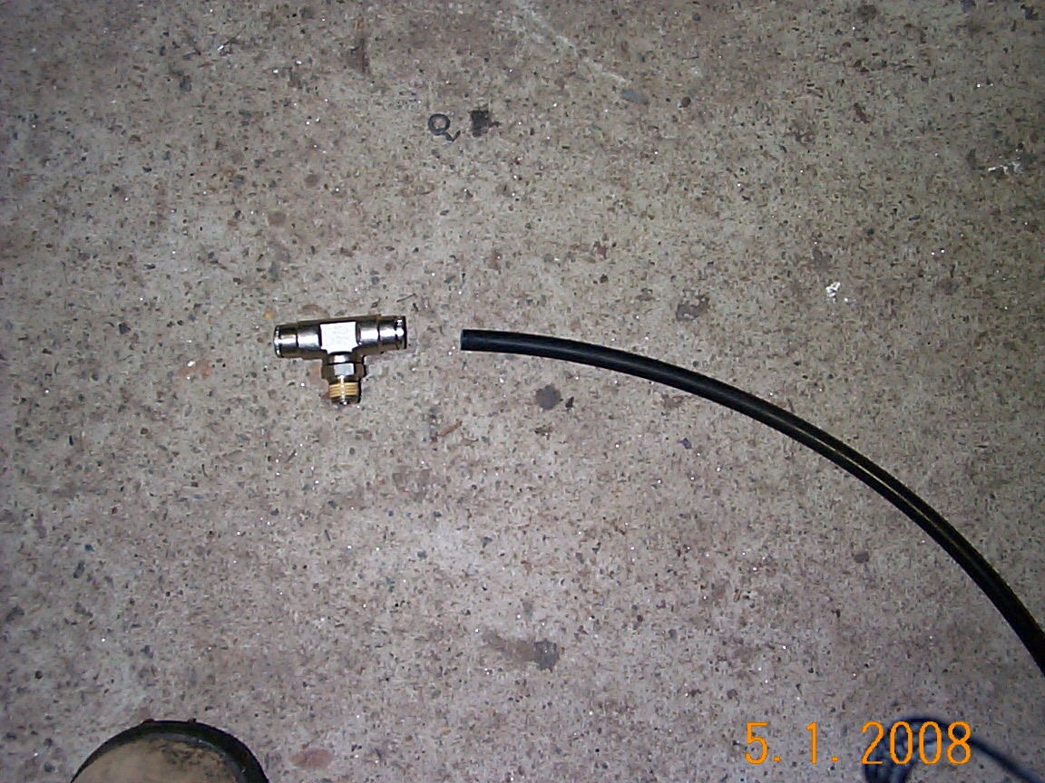

Compressor and dryer mounted in back of the Humvee

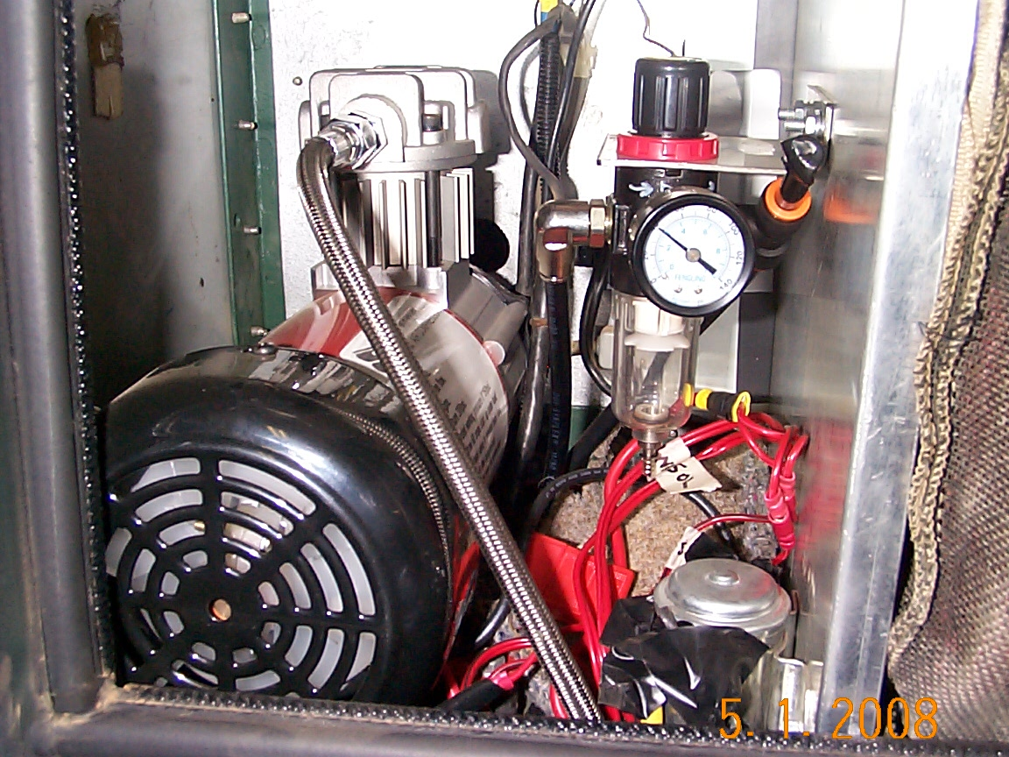

CTIS valve, Hummer tire pressure gauge, toggle for inflate/deflate and red switch for compressor

