Shock Replace
Tools Needed:
- 1 ½” socket
- Torque wrench able torque 300 ft-lbs
- 11/16” socket
- Ratchet Drive / Impact / Breaker bar
- Floor Jack
- Jack Stands
- 7/8” Socket
- CTIS Wrench (if equipped)
- Vice
- 1 ¼” wrench or a Crescent Wrench
- HMMWV Torque List --- www.amghummer.com or www.ihog.info (documents)
- Part numbers are located at the end of this article
- 1 extra set of helping hands

Removal:
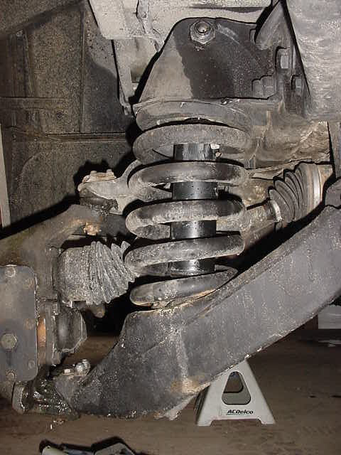
Shock
Suspension with tire off

The easiest way to attack a shock is to remove the tire first. Jack the truck up, place the jack stand under the frame and rest the frame on the jack stand. Remove the CTIS / Wheel (not needed but it does make it a LOT easier). With the 11/16” socket, remove the bottom two bolts holding the bracket onto the lower control arm.

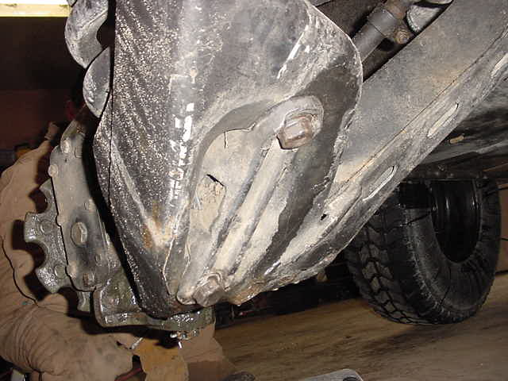
Shock Lower Bracket
Remove these bolts
Bottom of Shock in Lower Control arm

Once the lower bolts are removed grab a pipe and your 1 ½” socket with breaker bar and remove the upper shock bolt (cresent wrench / 1 ¼” wrench). Once the nut is removed, pull the bolt out and the shock will drop out of the truck (might need to tap it past mud and dirt).

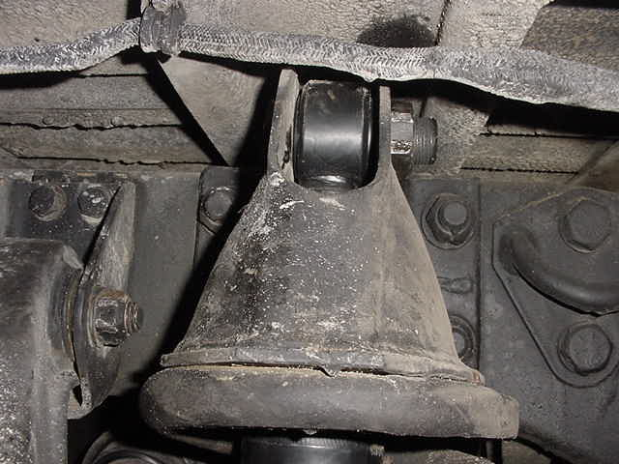
Upper Shock Bolt

Take the assembly over to a vice and install the shock into a vice. Remove the lower shock bolt using the same tools for the upper shock bolt. Note, do NOT stress the ears of the mounting bracket as they will break

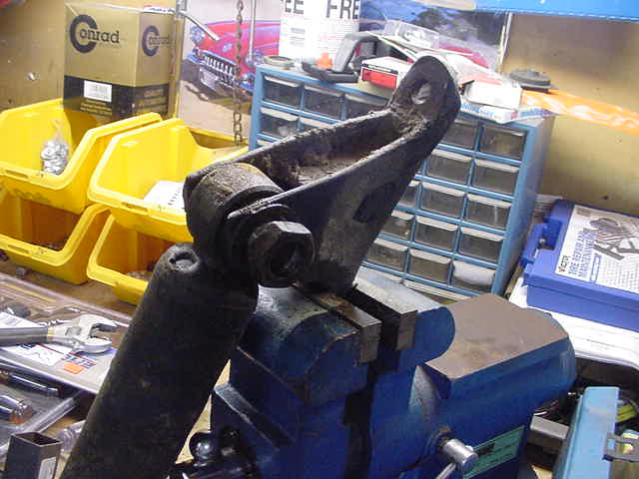
Shock in vice with lower bolt loose

Remove the lower bolt, and remove the shock.

Instillation:

Install the new shock in the same orientation as the old one with the solid part attached to the bracket and the rod end opposite. Torque the lower bolt to 300 ft-lbs. When tightening the shock make sure that the shock will make a line with a bracket as the picture shows for ease of instillation back into the truck.

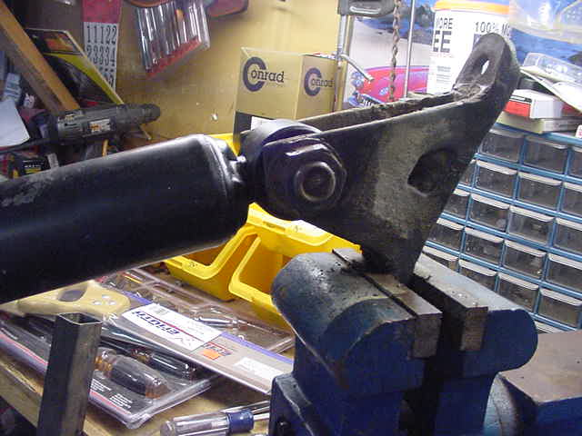
Aligning the shock to the bracket

After the lower bolt is torqued, place the shock back into the truck and tighten down the lower bolts after fully extending the rod. Torque the lower bolts to 178 ft-lbs. Now re-install the upper bolt, you might need to use the jack to compress the suspension a bit before the bolt will go back into the same hole (lift up the control arm). Install upper bolt and torque to 300 ft-lbs.

Part Numbers
Front / Rear GVWR Part Number NSN

Front 7700 X-66859 2510014222818
Rear 7700 70114 2510012515316
Front 10,300 12340071
Rear 10,300 12340072
Front 12,100 5937865

