H2 Canister Vent Solenoid Repair
Symptoms:
  - Slow to fill up the fuel tank
  - Check Engine Light setting a P0446 Code (EVAP Restriction / performance)
The Canister Vent Solenoid (CVS) on the H2 is used for diagnostic purposes. When it’s not running diagnostics, it is in place acting as the vent allowing for the air inside the fuel tank to escape and make room for the fuel during refueling, or to allow air to come in while you are consuming fuel. Since it is a solenoid, there is a filter on the “dirty” (atmosphere) side of it. When this filter gets clogged, you will experience the symptoms listed above. The CVS is located under the driver’s side rocker panel on the H2.
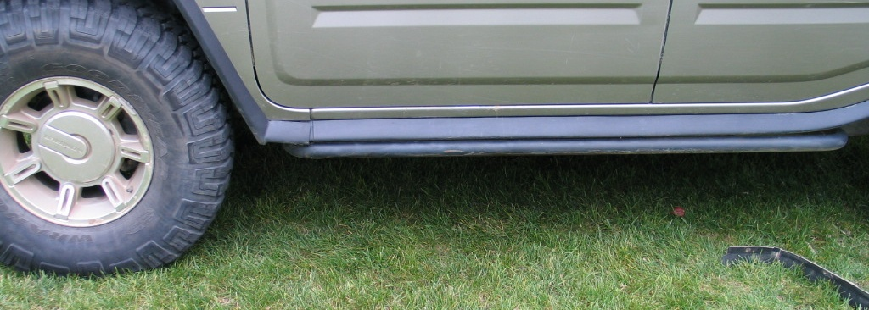
Figure 1: Location of the CVS Drivers side Rocker Panel
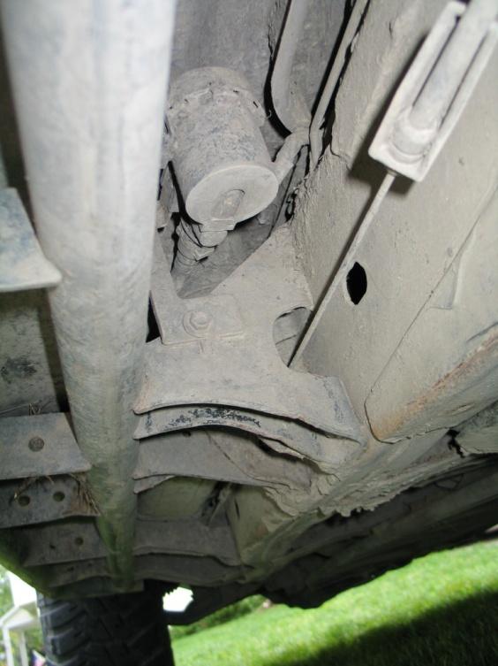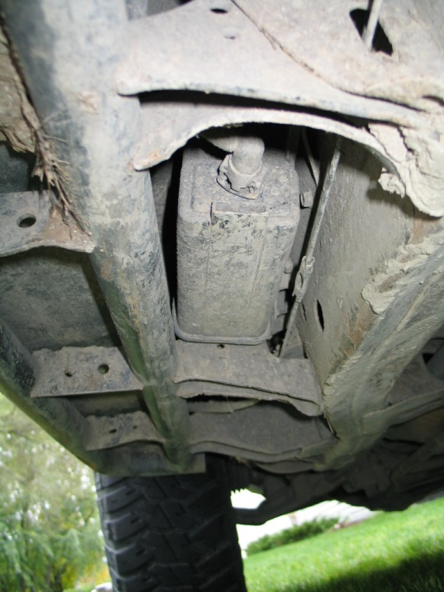
Figure 2: CVS Location Figure 3: Canister Location
The CVS is mounted “above” the rated water line for the H2 however, as you can see in the above pictures, it can get rather dirty in this location. The big round thing in figure 2 is the filter for the CVS, this is what needs to be cleaned. In figure 3, you see the rectangle thing, which is the canister. The canister’s job is to strip the hydrocarbons from the air that is looking to escape from the fuel tank when you go to fill your Hummer. It does this by having the fuel vapors pass through a chamber(s) of carbon.

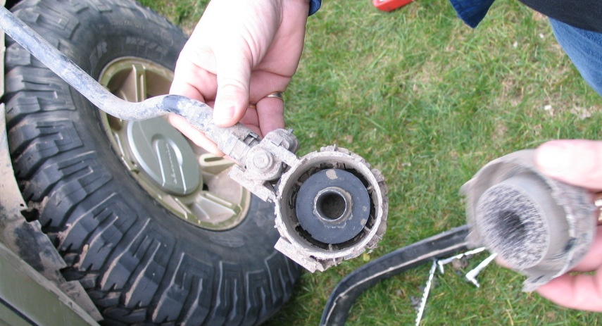
1.
2.
3.
4.
Figure 5: The CVS’s filter removed

In figure 5, number 1 is pointing to the fresh air hose that comes from the canister to the CVS. Number 2 is the CVS itself, which is what the electrical connector clips into. Number 3 is the filter assembly with the cover removed for the CVS. The air comes in and goes out slots around the circumference of this filter. Number 4 is the cover for this filter assembly – which is easily removed with a screw driver.

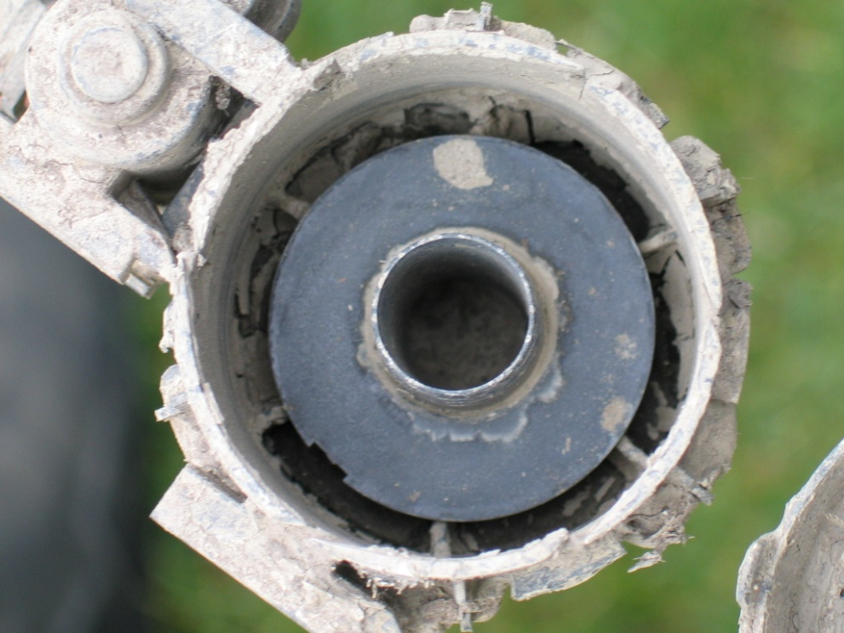
Figure 6: Close up of the dirty CVS filter
As you can see in figure 6, the filter assembly is full of mud. This filter is capable of holding some mud / dust / sand / water, but there is a limit. After each off-road trip is would be wise to check this filter if you have gone through deep mud.

Figure 7: Tab to remove CVS Filter

In figure 7, you can see the arrow pointing to the tab that when lifted, the CVS filter can be rotated and removed from the CVS. This removal can be done by leaving the CVS in the truck, and removing the filter for cleaning. When the filter is removed, remove the cover for the filter as shown in the picture and use water to remove and dirt / debris. Dry the filter and then replace the filter to the CVS.

If you do not wish to do this “maintenance” in cleaning the CVS filter assembly, there is another option. GM Sells several different variants of the CVS for their Full Size Truck products. You could purchase a CVS that breathes different, through a port, and install it to your current setup. With that, you can attach a hose to vent in a “clean” location. I have found a good location for this is in the pocket behind the driver’s side rear wheel zip tied to the filler pipe.

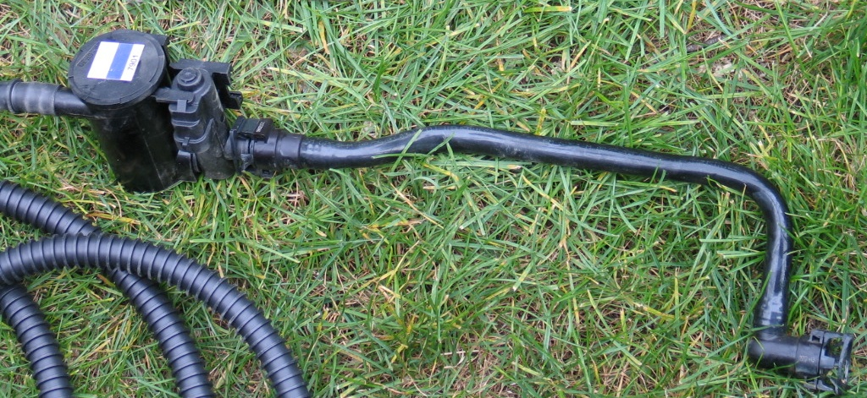
Figure 8: New CVS Filter to old CVS / Hose

As you can see in figure 8, there is another option that you could purchase from a GM dealer to make your system more robust. The filter assembly in this picture can be purchased, this particular filter happens to have a long hose swedged on it. You can use just a simple “heater” hose if you choose, just be sure to not kink the hose or collapse it, as this is what you will need for your fuel tank to breath. The GM PN for this CVS Filter is 25932570.

At the end of the hose, (to the left of the picture in figure 8) you should have something to “pre-filter” the system. It happens that GM has one of those for sale too. Its PN 19152347.

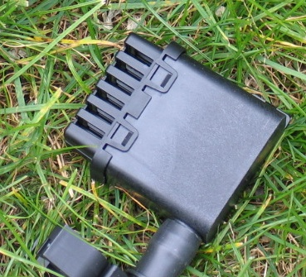
Figure 9: CVS Pre-filter

The pre-filter shown in figure 9 works very well at the end of the CVS “snorkel. The “vent” should be placed with the vents facing the ground (you don’t want water to collect in it). If you are using heater hose you could zip-tie this at the one end of the hose. GM also has a kit with both of these parts included, the CVS and pre-filter (you supply the heater hose / zip-ties) which is PN 19152349.

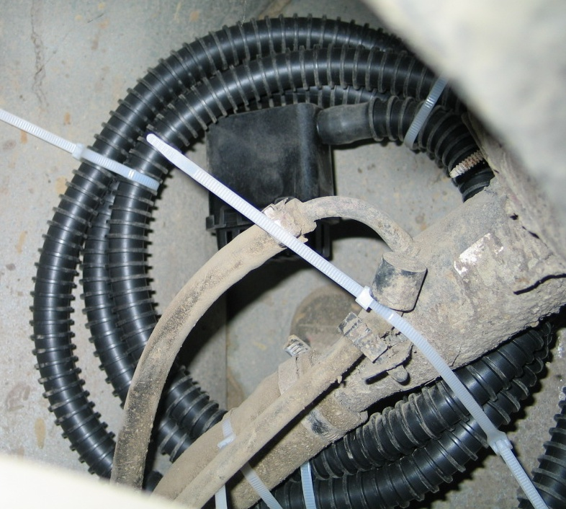
Figure 10: CVS Snorkel mounted to the filler Pipe

Here in figure 10 you can see the snorkel mounted to the filler pipe. After quickly removing the driver’s side wheel liner, the filler pipe is easily seen. It seems to be a fairly clean location, as on the truck I was working on, there were many spots that didn’t have much mud on them. Zip tie your snorkel to the filler pipe, and avoid pinching the snorkel for your differential (as seen in this picture). Afterwards you should be good to go. In the future if you have issues, you now know where to look, and it’s a relatively simple repair / modification to potentially save you a lot of time and frustration!!

