6.2L Rear Main Bearing
Seal Replace

Tools Needed:
- 2 Jack stands
- Floor Jack
- Misc. shop tools (sockets / extensions / ratchets)
- Oil Drain Pan
- Permatex gasket sealant
- Torque Wrench
- Part numbers are located at the end of this article

Removal:

For safety, disconnect the hot lead to the battery. Drain the engine oil out of the engine. Re-install the drain plug to stop any residual oil from dripping out. Remove the starter, or if possible move it aside so that you can get at the oil pan bolts. Remove the flywheel cover (this may require to remove the exhaust Y-pipe). Remove all (24) bolts of the oil pan, and then give the oil pan a good hit with your hand to break it free. Drop and remove the oil pan (place a towel under the engine to catch oil drips).

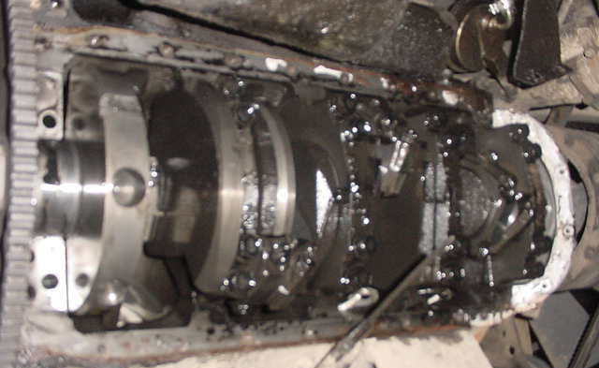
Crankshaft
Dipstick
Flywheel
Connecting rod / rod bearing caps
Main Bearings
Crankcase with oil pan removed (oil pump / rear-main not installed)

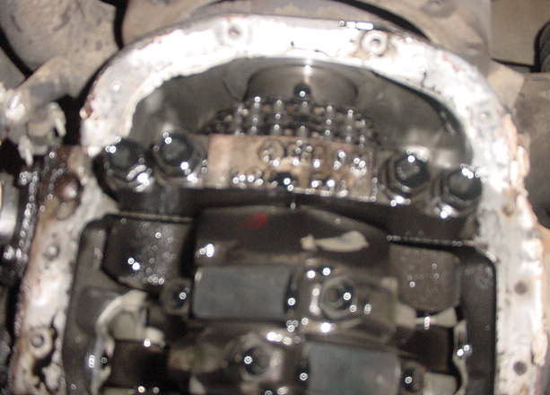
Timing Chain
Main Bearing
Rod bearing caps
Front of engine with cover off (sorry for blurry picture)

While the oil pan is off, inspect your timing chain (for slop some is good, but not too much), flywheel (for ground teeth), cylinder walls (for scraps / scares / blow by marks), connecting rods (for excess play) and main bearings (for excess play). Replace worn items as necessary. If rod / main bearings and cylinder walls are showing excess wear, consider replacing / rebuilding the engine.

Remove the oil pump and rear main bearing. Just for precautionary measures, replace the oil pump with a new one. Inspect the rear main bearing face and crankshaft mating surface for any excess wear / mars. Pull the seal out of the bearing cap use a small screwdriver or al to remove the seal that is still in the block. Clean all mating surfaces of the oil pan and engine block for the re-installation.

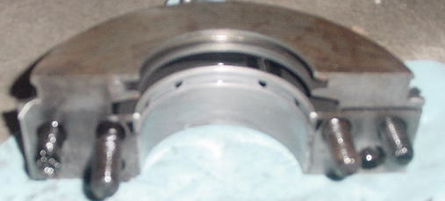
Bearing seat
Seal seat
Rear Main Bearing Cap (seal removed)

Installation:

Clean all mating surfaces of the oil pan / engine block of old gasket residue and oil. Slide the new main bearing cap seal into place, leaving part of the seal hanging down. The reason for the seal to hang down, is that then the halves will not match up with the halves of the main bearing cap. Reinstall the rear main bearing cap finger starting the bolts.

Once the cap is installed (make sure that the bearing is still in there in the same orientation it came out as) torque all of the bolts to 40ft-lbs. After all bolts are initially torqued to 40 ft-lbs, torque the short bolts to 100 ft-lbs and the long bolts (inner) to 110 ft-lbs. Install the new oil pump (can install old but I recommend spending the small amount of money to get a new pump). Torque the stud to 59ft-lbs, be sure to align it properly into the correct grooves in the bearing cap. The nut holding on the support arm is to be torqued to 35 ft-lbs.

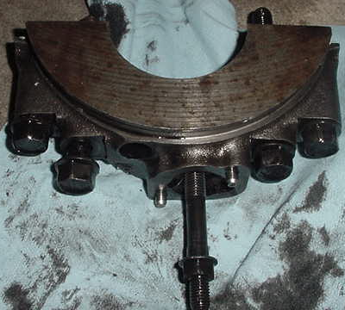
Oil Pump Mounting location
Outside face of bearing cap
6.2L Rear Main Bearing Cap

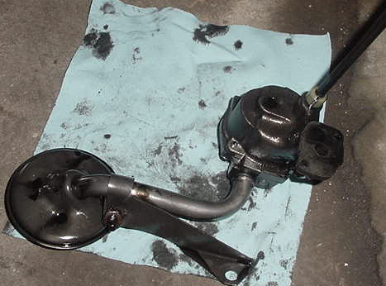
Pick-up screen
Pump Drive
Support Arm
Oil Pump Mount
Front of vehicle
6.2L Oil pump

After getting the oil pump back in place and torqued down, the oil pan needs to be re-installed. Generously apply Permatex gasket sealant onto the oil pan mating surface (after of course each surface is cleaned, engine block and oil pan) *note: apply excess amounts where the rear main cap, oil pan and block all meet. The next step is to re-install oil pan to engine by finger-starting the bolts to hold the pan into location. Finger-start the remaining bolts to ensure location and alignment. By using your extension and socket, hand-tighten the bolts that hold the oil pan on. Do not torque them down yet as you want the gasket material to harden somewhat before you achieve final torque. After letting the gasket sealant harden some (about 1 hr later) torque the remaining bolts down until they are hand tight with your wrench. Make sure that you have the two studded fasteners in the proper location so that you can re-install the wire harness bracket.

After the oil pan is fully installed, reinstall the starter. Torque the starter bolts to 40 ft-lbs with thread locker blue. Re-install flywheel cover and fill the engine with the proper engine (most common 15W-40). Start engine; listen for any odd noises, if any noises occur trouble shoot.

Part Numbers

Rear Main Seal National 5163

Oil Pan Gasket Set ROL OS6037
Oil Pump AMG 5740541 (try a GM dealer for this part
also)

Note: To do this maintenance on a 6.5L NA or Turbo, the transmission must be removed since the seal is a one-piece seal.

Work done on a 1985 M998 6.2L Diesel

