Wiper Pivot Arm Install

The pivot arm for the wiper assembly is located in the windshield, and connects the linkage from the motor to the wiper arm.

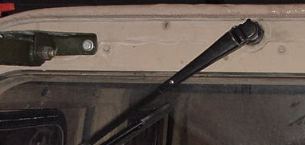

Picture of the complete exterior of the assembly

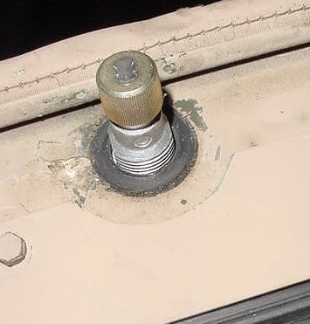

Picture of the Wiper Arm Pivot from the outside of the truck

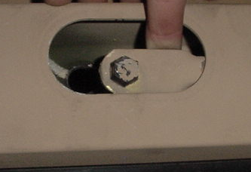

After removing the plastic cover, the back of the pivot arm
can be seen as this picture illustrates.

Removal

Once the wiper arm is removed (screw driver might help to undo the locking) the retaining nut is easily accessible. Remove the nut and press on the pivot arm. The arm should fall back into the windshield frame. With aid of a screwdriver (or some prying device) pry the linkage socket joint off of the pivot arm ball joint. Remove the pivot arm assembly.
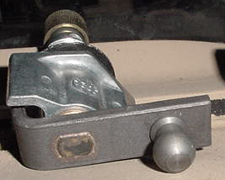

Picture illustrating the ball joint where the motor linkage attaches.

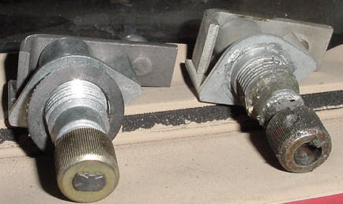

New Style Old Style

The above shows the old style pivot arm where the shaft was circular and had a pressed fit between it and the spline, which holds the wiper arm on. The new style has a rectangular interface between the shaft and the spline ensuring that the spline will not rotate off (like the old style did). If this is to happen, your wiper arm will stop moving and the motor will continue to run (the arm may catch every once in a while. The wiper arm will also show excess play when this pivot arm is / has gone bad.

Installation

To install the pivot arm, be sure to grease the ball where the linkage attaches. Press the pivot arm into location with the “wings” pointing upward allowing the ball end to swing like a pendulum. Then install the nut on the exterior of the windshield with the washer and gasket provided with the new part. To get the linkage back on after the pivot arm is secured in the windshield frame, take a 9/16” socket (deep well or extension) and give it a good whack with a hammer or similar to seat the linkage. Conduct a pull test with your fingers to ensure that the linkage is installed, then turn the wiper on and watch for any bind ups. If the linkage is binding up the “wings” probably are not level and will need to be for proper operation. Once complete, install wiper arm and plastic cover. And remember… HAPPY HUMMERING

Note: Humvee Owners – to convert your wipers to the civilian wiper (standard 12”) all you need is a new 12” blade and a civilian arm.

Pivot Arm Part Number 12340660 (included – pivot arm, gasket, washer, nut)

Work performed on a 1985 M998 Humvee

