Relocation of the Warn Winch Hand Controller Plug-In Connection
Gilbert Herman, PhD, MD

Once again, Michigan road salt destroyed the plug on the winch for the hand controller connection. This time I had additional damage that included the motor brushes seizing and the ECL board malfunctioning so the winch could line out but not line in.

The Electronic Circuit Limiter sets an upper limit on current flow to the winch motor. The winch is rated at 12,000 pounds, but is capable of generating 20% more if the ECL is disabled. The ECL is a safety feature to prevent mechanical failure of components due to excessive loads. In addition, the ECL receives signal from a thermister on a motor brush to shut down the unit if the motor temperature exceeds a company-defined limit. It is best not to disable these components, however, in my case the road salt destroyed them. These parts are not available for purchase individually from Warn.

This paper will resolve the hand controller connection and ECL problem via bypassing the ECL and relocating the connection to a location further away from salt spray, yet easily accessible for plugging in the hand controller when in deep snow or mud.

The winch must be dropped, the plastic cover removed to expose the solenoid pack.
TO REMOVE THE WINCH

Disconnect the main wires that connect the winch controller to the battery. Remove under carriage protection plate and support the winch with a jack.
Remove hook or clevis and pass winch line through the mounting plate opening. Remove the four bolts that anchor the winch (see illustration) and lower the jack.
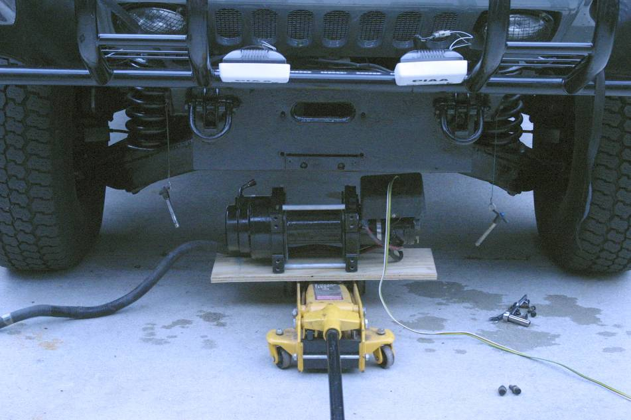

I removed the original hand controller connection by drilling the rivets. I passed the four lead wires through the hole in the plastic cover. I then connected the circuits to the solenoid pack.

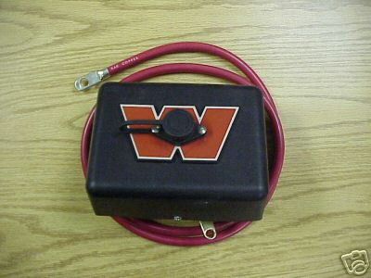
Drill out these rivets to remove original hand control connection.

The original wire colors for the hand controller were white (always hot), black (line out) and green (line in). The four-wire trailer harness used: yellow (not used), white (always hot), green (line in) and brown (line out). I soldered circular crimp ends on all wires.

The plastic or tar that covers the entire solenoid pack must be removed to expose the needed connections only.

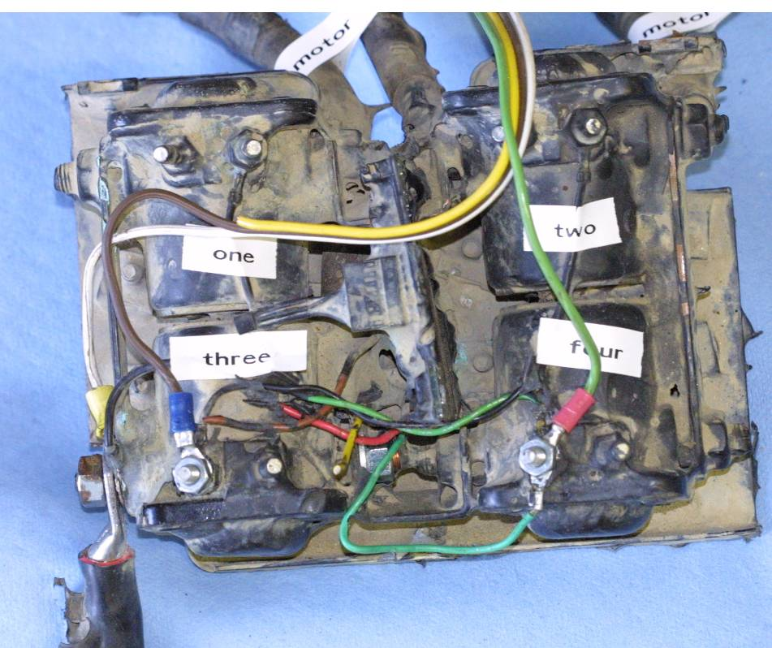

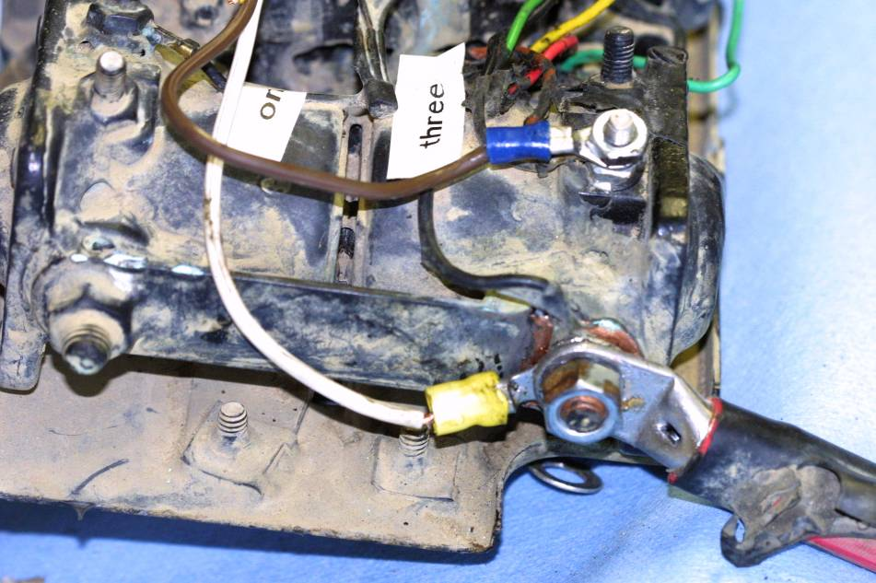
The four color trailer harness is connected as follows: green to the left terminal of solenoid four, brown to the left terminal of solenoid three, white to the main battery positive harness connector with the yellow not used. This connection will bypass the thermal sensor in the motor and the ECL board. To keep these components in the system, connect the green hand controller wire to the green wire that enters the motor housing (not the green wire that exits the motor housing and connects to the ECL).

All connections – crimped and soldered

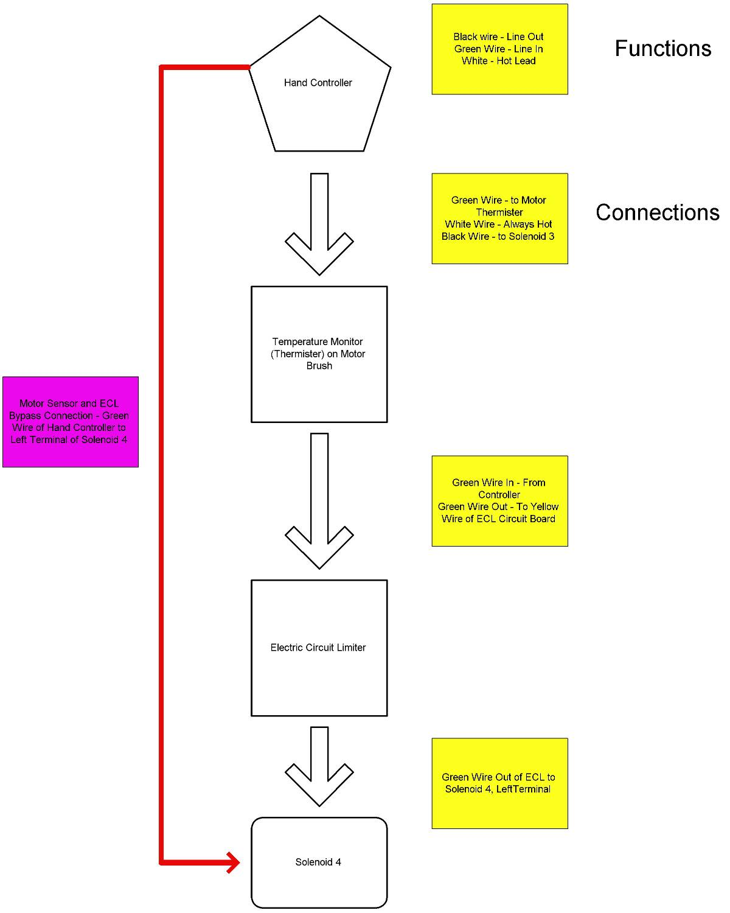

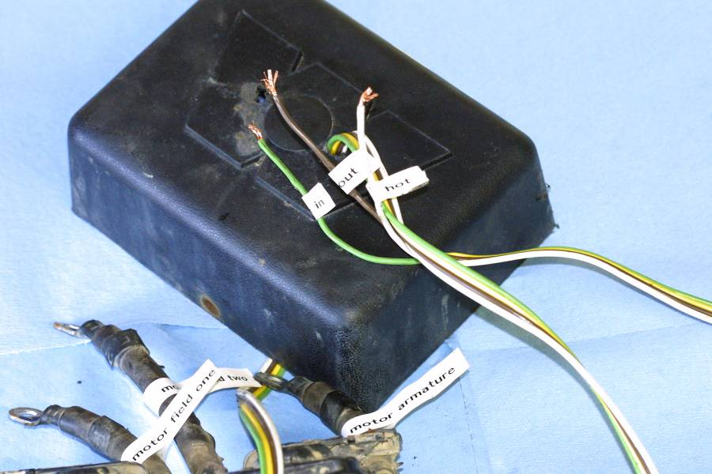
The original hole was capped and smaller hole drilled for passing the trailer harness. All openings were filled with silicone caulk on the internal surface.
I then labeled the wires that exited from the plastic housing.

Wires were zip-tied to the metal controller mounting plate to prevent accidental dislodgement. All exposed wire and solenoid components were thoroughly coated with silicone then the plastic cover bolted to the controller pack.

The winch was then placed back into the truck using a board and a 3-ton jack. Alignment of the boltholes is hastened by using a Phillips screwdriver to position the winch unit. Since the winch is on a board it can easily slide on the jack head.

The hand control and new controller connector are then prepared for rewiring. The road salt destroyed the original female Warn Connector on the winch. The original Warn male connector on the hand controller had to be cut off. I changed the connections to a standard 4-Pole Round Trailer Harness Male and Female connectors available from www.trailerwiring.com. I used: Hoppy 48305 – 4-Pole, vehicle end and 48325 4-Pole, trailer end. I purchased this from my local automotive supplier (Pep Boys).

Disassemble the new female trailer connection. Pass the wires of the controller harness through the grommet. Then, strip ¼ inch of wire covering and solder the end for the brown, green and white wires. These are inserted into the new connector pins and are held with Phillips set screws. The procedure for the hand control is similar. Remove the original connection end and discard.

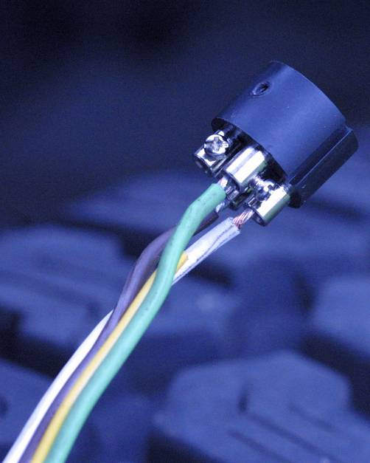
This is the female connector plate.

Remove the metal housings from both units, have the male and female plugs properly aligned and connected to each other when attaching the wires to their respective posts. This prevents wire misalignment.

Once all wires are connected, fill the hand control housing with silicon caulk; slide the connector plate into its housing and insert the setscrew.

The female connector cannot be final assembled until it is placed into the final mounting position on the truck.

The new female controller connector is now mounted on the truck. I chose the metal plate that covers the original wire harnesses that connect the turn signal. The winch harness was router through the grommet with the turn signal harness. The hole sealed with silicon caulk.

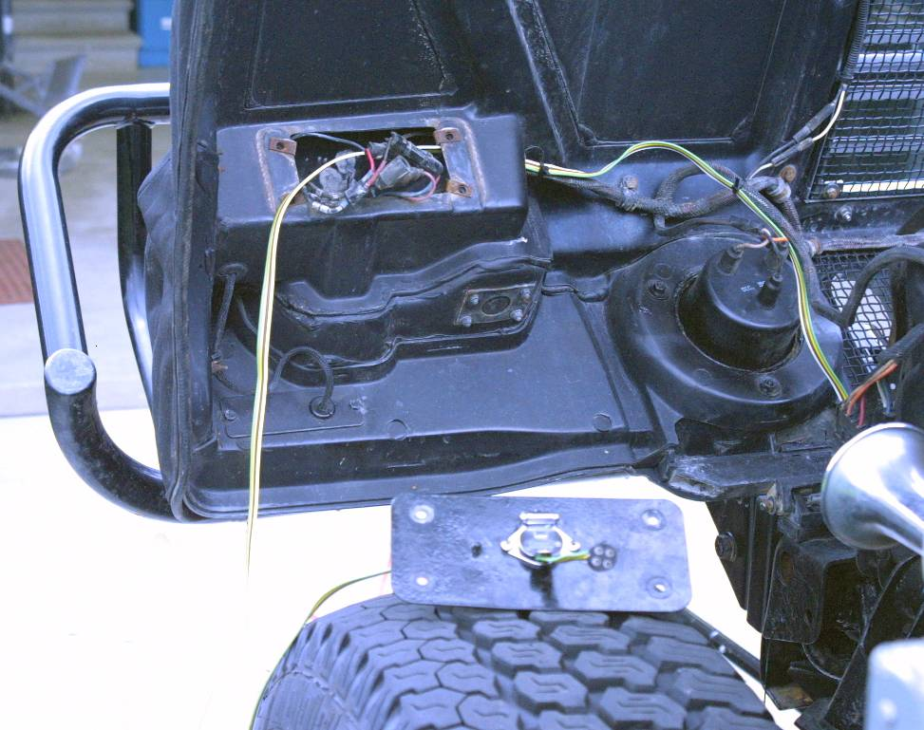
The hood turn signal plate is drilled with the female trailer harness connector attached. All surfaces are coated with silicon caulk.

The metal plate was removed and a one-inch hole drilled for the female housing as well as 2 smaller holes for bolts that hold the connector to the plate. I used stainless steel bolts and locknuts to hold the unit. The metal cover plate is sealed to the hood with silicone caulk.

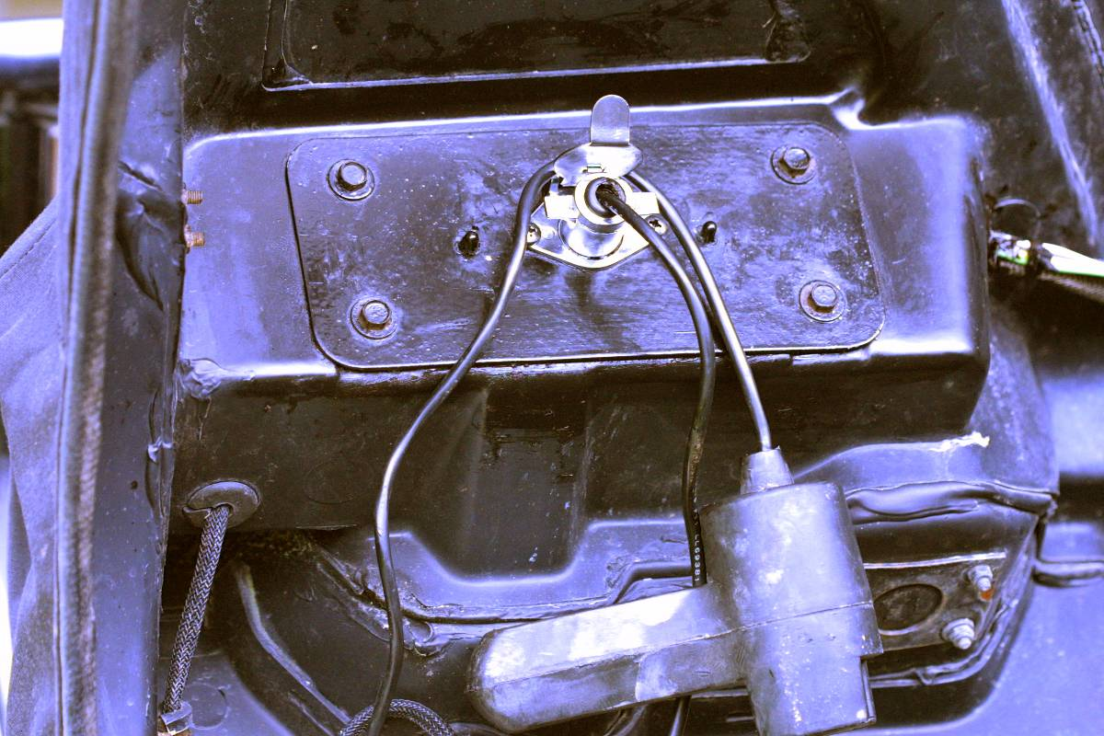

With the solenoid pack bench tested, I obtained the following voltage readings. This would be different for two readings if the pack were connected to the motor.

When the pack is connected to the motor, 12 volts will also be present in the opposite unenergized Field Coil Wire as it returns to the solenoid pack. The voltage then travels to the wire connecting the solenoid pack to the motor armature.

This voltage is returned to the solenoid pack after passing through either the Motor Field Coil 1 or the Motor Field Coil 2 circuit. The direction of travel is 180 degrees out of phase depending upon which of the two Field wires is energized so the motor has a forward and reverse action.

This voltage will then travel through the motor brush-armature system (two brushes with 12 volt charge, 2 brushes with connection to ground) to induce magnetism in the armature coils. The armature will then spin in the coil-induced magnetic field.

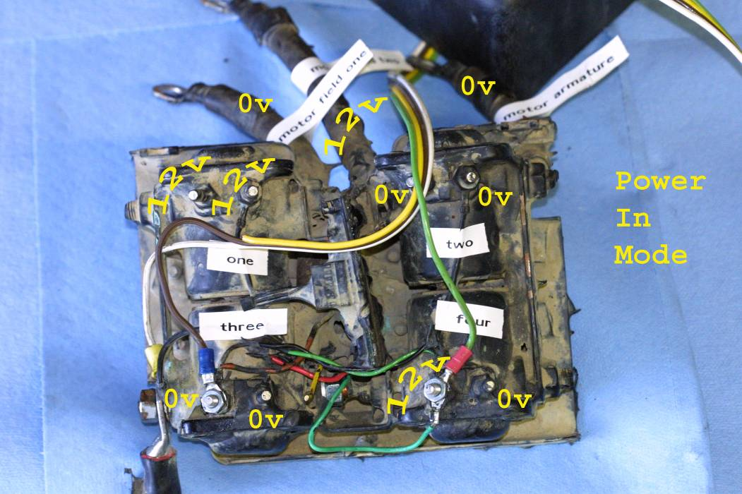
If the solenoid pack were connected to the motor, voltage would return to the pack by the opposite Field wire and then travel to the Armature of the motor.

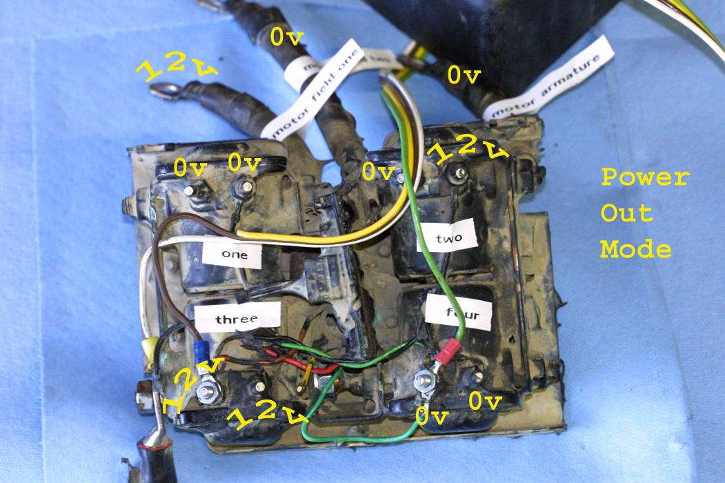

To more fully understand the solenoid connections, it is easier to see them in a non-sealed unit. This picture is from a control pack for the Warn 6000 series. The large copper connections between the solenoids are now easily seen.

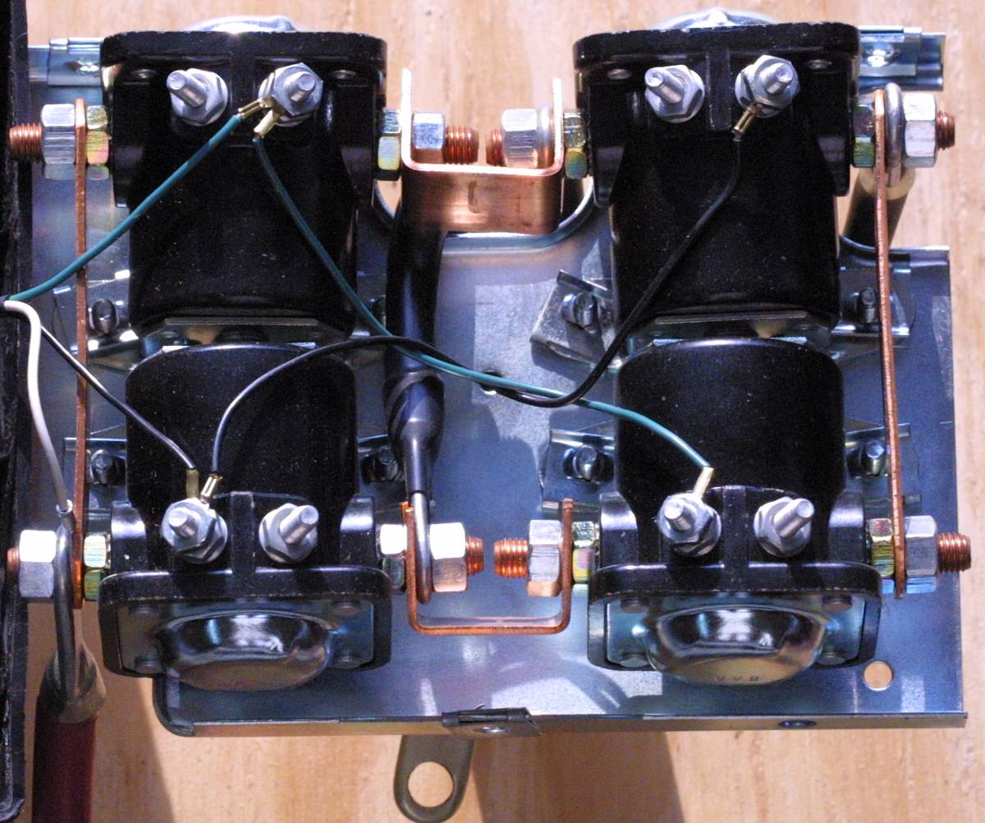

Here the solenoid pack is connected to the original female hand controller plug. The black wire is hard to see in the photograph so look for the red arrow.

